Types of DNS Records
# Source: Chatgpt (GPT-5-Mini) at [1/18/2026]
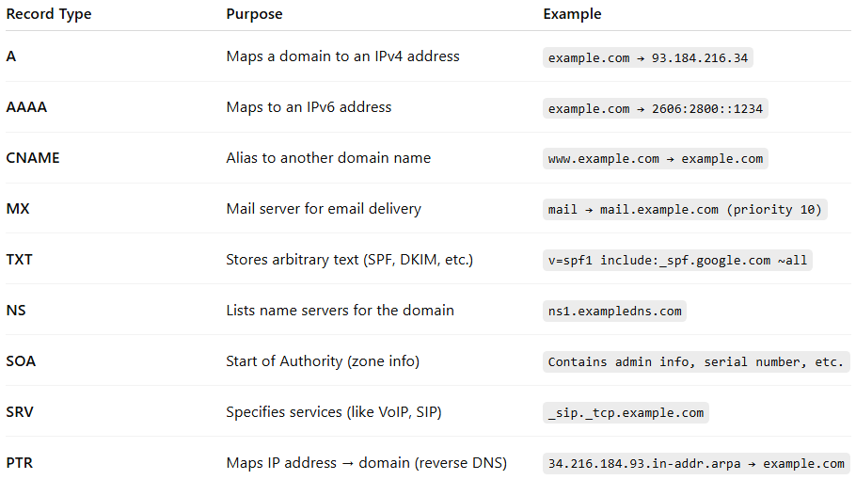

Record Type | Purpose | Example
A | Maps a domain to an IPv4 address | example.com → 93.184.216.34
AAAA | Maps to an IPv6 address | example.com → 2606:2800::1234
CNAME | Alias to another domain name | www.example.com → example.com
MX | Mail server for email delivery | mail → mail.example.com (priority 10)
TXT | Stores arbitrary text (SPF, DKIM, etc.) | v=spf1 include:_spf.google.com ~all
NS | Lists name servers for the domain | ns1.exampledns.com
SOA | Start of Authority (zone info) | Contains admin info, serial number, etc.
SRV | Specifies services (like VoIP, SIP) | _sip._tcp.example.com
PTR | Maps IP address → domain (reverse DNS) | 34.216.184.93.in-addr.arpa → example.com

